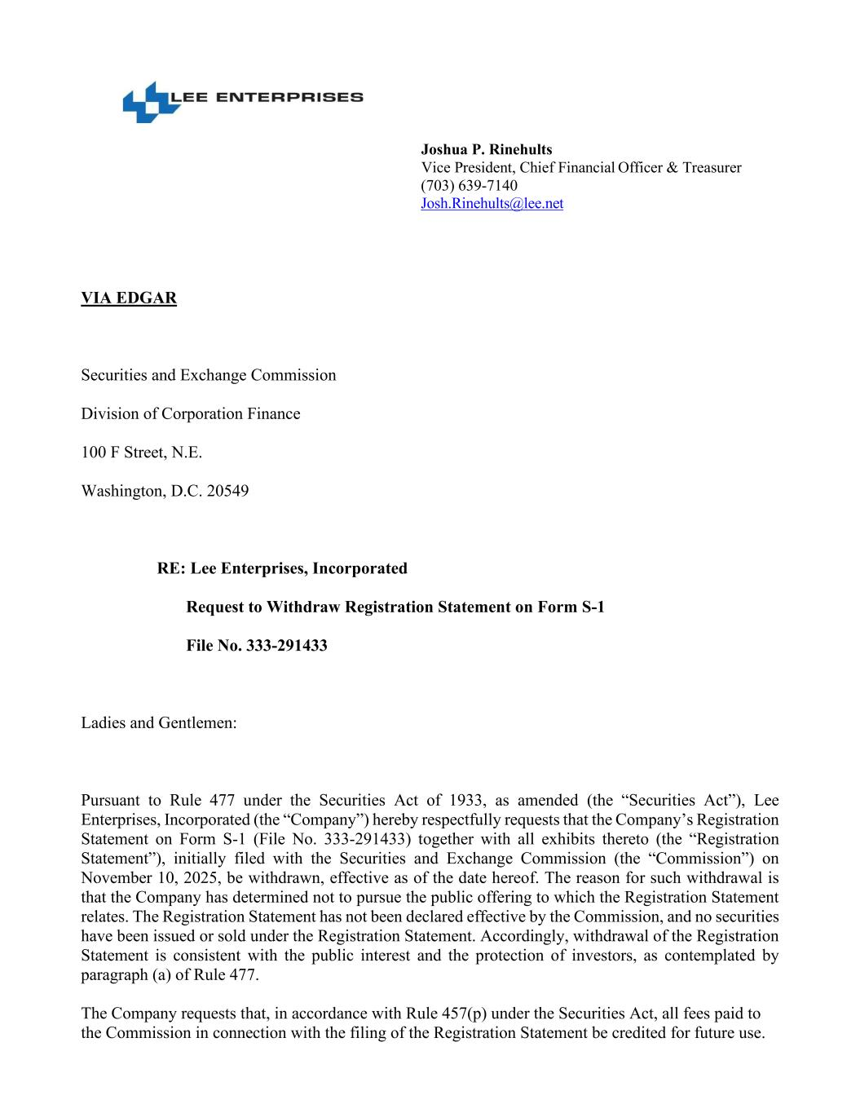
Joshua P. Rinehults Vice President, Chief Financial Officer & Treasurer (703) 639-7140 Josh.Rinehults@lee.net VIA EDGAR Securities and Exchange Commission Division of Corporation Finance 100 F Street, N.E. Washington, D.C. 20549 RE: Lee Enterprises, Incorporated Request to Withdraw Registration Statement on Form S-1 File No. 333-291433 Ladies and Gentlemen: Pursuant to Rule 477 under the Securities Act of 1933, as amended (the “Securities Act”), Lee Enterprises, Incorporated (the “Company”) hereby respectfully requests that the Company’s Registration Statement on Form S-1 (File No. 333-291433) together with all exhibits thereto (the “Registration Statement”), initially filed with the Securities and Exchange Commission (the “Commission”) on November 10, 2025, be withdrawn, effective as of the date hereof. The reason for such withdrawal is that the Company has determined not to pursue the public offering to which the Registration Statement relates. The Registration Statement has not been declared effective by the Commission, and no securities have been issued or sold under the Registration Statement. Accordingly, withdrawal of the Registration Statement is consistent with the public interest and the protection of investors, as contemplated by paragraph (a) of Rule 477. The Company requests that, in accordance with Rule 457(p) under the Securities Act, all fees paid to the Commission in connection with the filing of the Registration Statement be credited for future use.

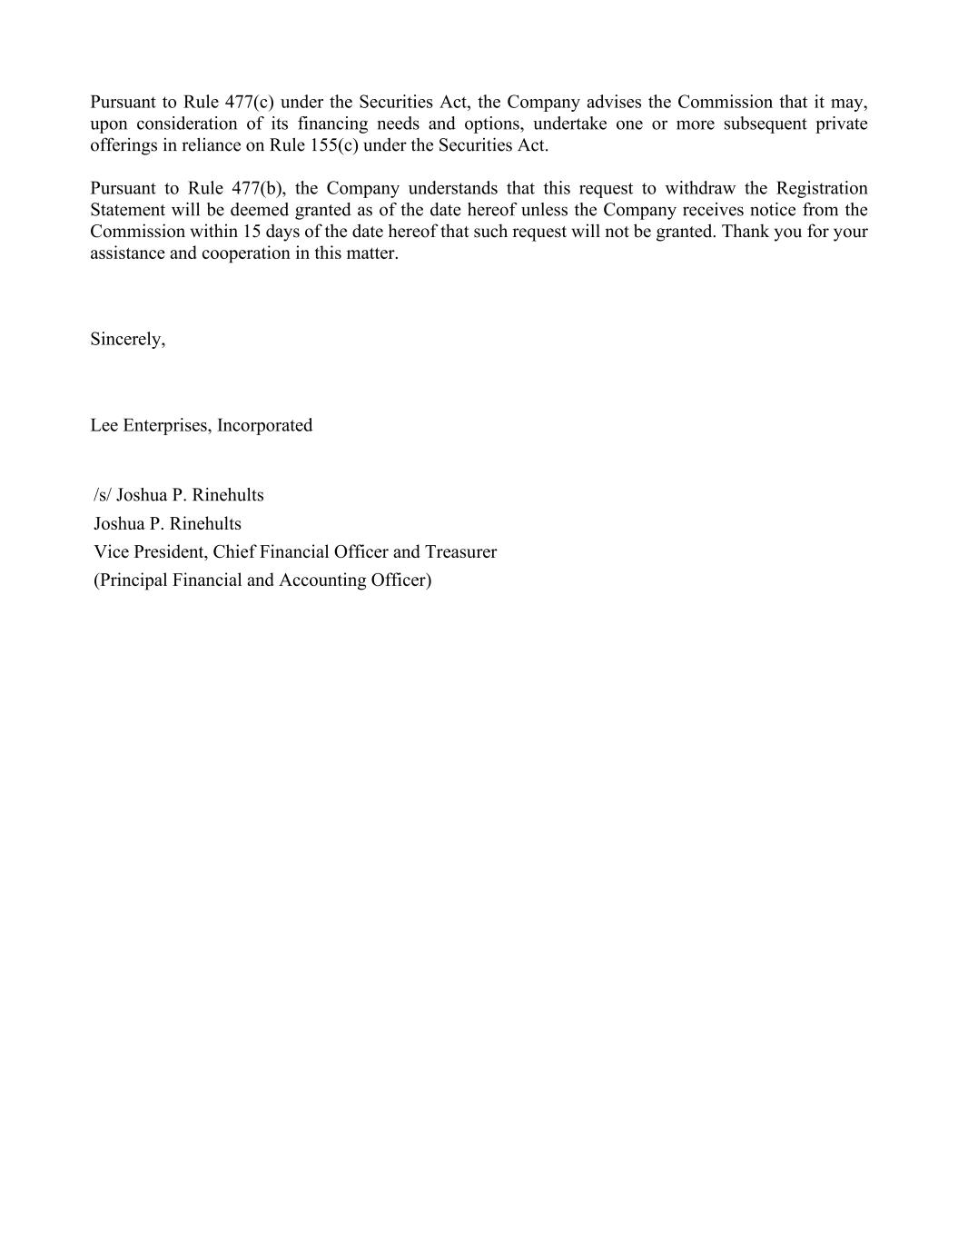
Pursuant to Rule 477(c) under the Securities Act, the Company advises the Commission that it may, upon consideration of its financing needs and options, undertake one or more subsequent private offerings in reliance on Rule 155(c) under the Securities Act. Pursuant to Rule 477(b), the Company understands that this request to withdraw the Registration Statement will be deemed granted as of the date hereof unless the Company receives notice from the Commission within 15 days of the date hereof that such request will not be granted. Thank you for your assistance and cooperation in this matter. Sincerely, Lee Enterprises, Incorporated /s/ Joshua P. Rinehults Joshua P. Rinehults Vice President, Chief Financial Officer and Treasurer (Principal Financial and Accounting Officer)

